Bridge System

Bridge Card Generator

# Table of Contents

Table of Contents

1.0 General Summary

1.1 Summary

1.2 Features

1.3 Manual Organization

2.0 System Summary

2.1 Requirements

2.2 Access Levels

3.0 Getting Started

3.1 Your First Use

4.0 Using the Software

4.1 Create A New Deck

4.2 Creating Boards

4.3 Open/Edit/Save A Board

5.0 Creating Images and Documents

5.1 Creating Images and Documents

6.0 Troubleshooting

6.1 Invalid Input

6.2 Images Not Being Created

# 

# 1.0 General Summary

General Summary will describe the purpose of the Bridge System Bridge Card Generator.

## 1.1 Summary

The Bridge System Bridge Card Generator was created to help Bridge players generate decks of cards that may be used in order to learn and practice Bridge. The software will be able to collect user input in the form of hands of cards and will generate images of the correct size and resolution required to display them on the back of a standard playing card. This system was designed for members of the Pensacola Duplicate Bridge Club.

## 1.2 Features

* The software will allow users to create decks containing 36 boards of 52 cards each.
* Each deck and board can be saved for later use as well and can be edited and deleted.
* The software will output a series of 53 images representing each card in a deck of standard playing cards. Each image will contain the position of the card in every board of a deck and the dealer of that particular board.
* The images created by the software are the correct size and resolution making them perfect for printing on the back of a standard playing card.
* In addition to creating images for every deck, the software is able to print out each board in a pdf form for easy viewing.

## 1.3 Manual Organization

This section will provide a brief summary of all of the sections in the User’s Manual. The User’s Manual contains six sections: General Summary, System Summary, Getting Started, Using the Software, Generating Reports, and Troubleshooting.

1. General Summary will describe the purpose of the Bridge System Bridge Card Generator.
2. System Summary will display the system requirements that will be necessary to run the Bridge System Bridge Card Generator.
3. Getting Started tells you how to install the Bridge System Card Generator and how to prepare it for its first use. Be sure to follow these instructions when setting up your new software.
4. Using the Software tells you how to setup your new software and how to prepare it for its first use.
5. Generating Reports will tell you how to generate and read reports that are produced by the software.
6. Troubleshooting will teach you how to fix common errors that may occur in the system.

# 2.0 System Summary

This section will display the system requirements that will be necessary to run the Bridge System Bridge Card Generator.

## 2.1 Requirements

To run the Bridge System Bridge Card Generator, your computer will need to have Java Version 7 or a later version of Java Runtime Environment installed your computer. The program was designed to work with Windows 7, Windows 8, and OS X.

# 3.0 Getting Started

This section tells you how to setup your new software and how to prepare it for its first use. Be sure to follow these instructions when setting up your new software.

## 3.1 Your First Use

The software will come in a zipped file folder that will contain the card generator software and a user manual. To install the software, follow the instructions below.

1. Download the Bridge System Bridge Card Generator zipped folder.
2. Unzip the contents of the folder to a location on your computer, such as your desktop. The software can be run from any directory on either a Windows or OS X operating system.
3. Open the folder labeled “Bridge System Bridge Card Generator” that you just saved in a convenient location on your computer.
4. Locate the “BridgeSystem.jar” executable file within the folder and double click the file with your mouse to open the program, which presents the user with a home screen.

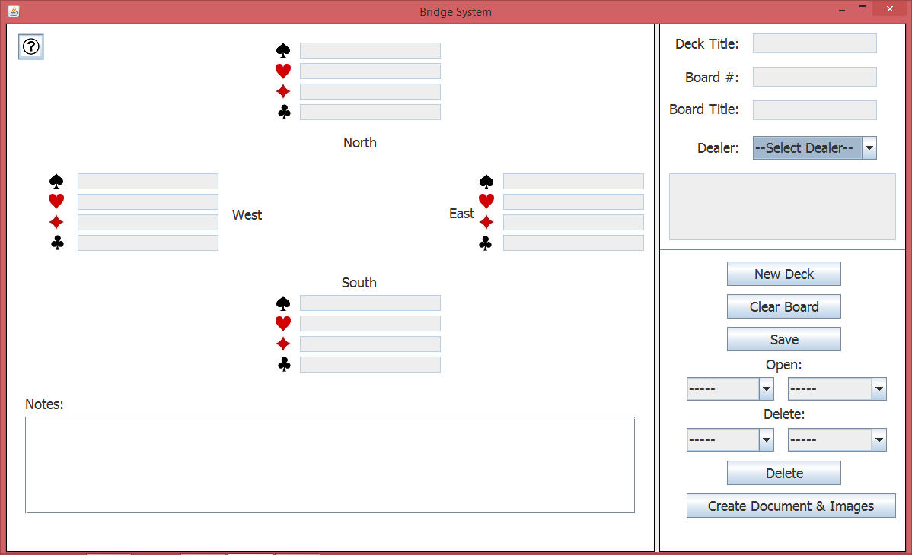

Figure Home Screen

# 4.0 Using the Software

This section will teach you how to create new decks and boards, as well as various functions. For more information on generating images, go to Section 5.0.

## 4.1 Create a New Deck

1. On the lower right side panel, click the button labeled “New Deck”.
2. A pop-up window will appear, prompting the user to input a name for the Deck under the label “Enter Deck Label”.
3. Click the Ok button.
4. A message will be displayed confirming that the Deck has been successfully made.

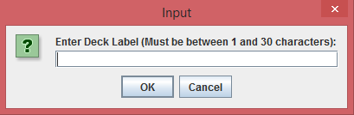

Figure Dialog box prompting the user to enter a label for a deck.

## 4.2 Creating Boards

After creating the Deck, you may then create 36 boards with cards and dealers placed by the user.

1. In the upper right side panel, type the board number under the “Board #” label. (I.E. 1)
2. In the text field next to the “Board Title” label, enter the name of the board. (I.E. Board 1)
3. Next to the “Dealer” label, select the desired dealer location from the drop-down menu.
4. In the left side of the panel, enter 13 cards in each of the four player locations. The format for inputting the cards should be either uppercase or lowercase. With the exception of any 10 card, all card values should be entered as their respected value. For example, K for a K card, 9 for a 9 card, etc. For the value of 10, a T or t should be entered. Also, the values do not need to be separated by a comma. (I.E. KJ98)
5. Once each player has 13 cards, click the Save button in the lower right side of the panel. A pop-up screen will follow letting the user know the board has been saved. Click the Ok button to continue.

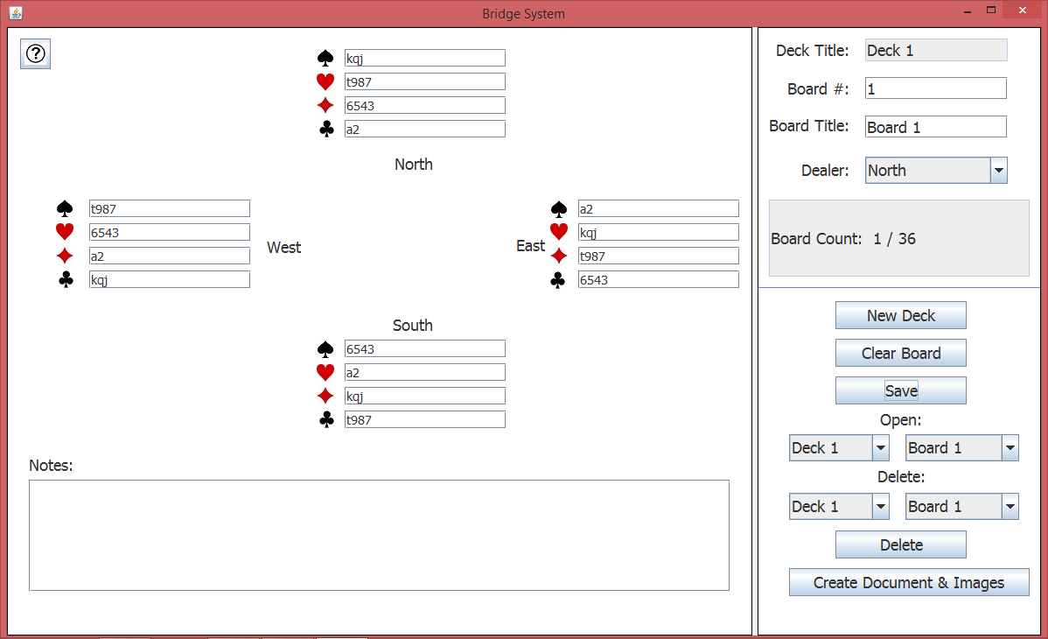

Figure Home screen with appropriate data for a board.

## 4.3 Open/ Edit/ Save Board

This function allows the user to open up any of the boards that have been created within a specified deck, edit them, and save any changes made.

1. In the lower right side of the panel, select the desired Deck with the Boards to be changed.
2. Once the Deck is selected, select the Board from the drop-down menu to be edited.
3. Enter any changes to be made within the Board (still ensuring each player has 13 cards).
4. Click the Save button; a pop up will appear to let the user know the Board has been successfully saved. Click Ok to continue.

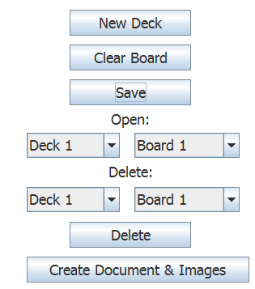

Figure Control Panel

**4.4 Delete Decks/Boards**

This function allows the user to select specified Boards and delete them.

1. Locate the “Delete” Label in the lower right side of the panel.
2. Select a Deck from the drop-down menu.
3. Select a Board from the drop-down menu.
4. Click the Delete button to delete the selected board (if desired); a pop up window will appear for confirmation to delete, click Yes.

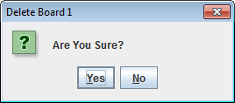

Figure Dialog confirming to delete a particular board.

# 5.0 Creating Images and Documents

This section will tell you how to create the card images and produce the PDF file containing the information contained on a board using the software. The PDF will contain each card a player possessed on that particular board and any notes the user included with that board.

## 5.1 Creating Images and Documents

The Bridge System Bridge Card Generator produces images and documents containing the information from a user-created deck of boards. You will need to have created a complete deck (one deck with 36 boards, each board containing 52 cards, with all cards in a board split amongst 4 players equally)

1. Click the button labeled “Create Document & Images”, seen on the control panel found on the bottom right corner of the home screen.
2. Select a completed deck from the dropdown menu and click “OK”.
3. The location of the images and documents can be found at the address specified by the program.

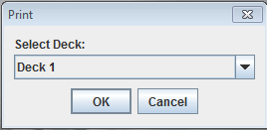

Figure Print Deck Selection Dialog

# 6.0 Troubleshooting

Troubleshooting will teach you how to fix common errors that may occur in the system.

## 6.1 Invalid Input

If you are presented with a message indicating invalid input when attempting to save a board, verify that the cards entered for each player are valid. Each of the 52 cards in a deck can only be entered once per board. All players must have 13 cards per board.

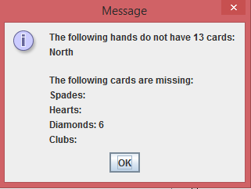

Figure Error Dialog for Invalid Input

## 6.2 Images Not Being Created

In order to create card images from a deck, all 36 boards must be completed. If any board is missing, the software will present the user with the following warning:

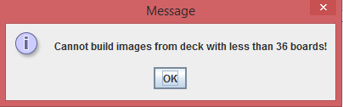

Verify that all 36 boards have been entered completely for a deck, and then attempt to create the images again.